**Trekking and Tours in North Sumatra**

**What to Bring**

The climate here is hot and humid so it is best to wear loose fitting and cotton clothing. If you have booked or planning to go jungle trekking, you don’t need special clothing or equipment but there are a few useful things to have especially if you’re camping in the jungle overnight.

**Suggested Clothing Items**

• **Shorts and T-shirts**

• **Long trousers, leggings and long-sleeved top for the evenings**

* Second hand clothes, like shorts, t-shirts, long sleeved tops, leggings etc. can be bought at the local market on Fridays and Sundays. The price is as little as 25p!

• **Swimming trunks (for men), swimsuit or shorts & t- shirt (ladies) - this is a Muslim country, please be polite and respectful! NO BIKINIS PLEASE**

• **Pair of walking shoes, trainers or boots with socks**

* Please not that walking boots can be heavy to walk in, especially on long treks. It’s also difficult to feel footing in the jungle and whether its slippy, take this from experience! If they get wet, they take a long time to dry.
* **Sandals or flipflops**

- flipflops with good grip can be bought cheap in Bukit Lawang…. Great for river walking. Also, these rubber shoes are light and have grips

* **Raincoat / jacket**
* **Cap or sun hat**

**Essential Items**

* **A day backpack** – 20 – 35 L for trekking
* **Sunblock** – its quite difficult to find in Sumatra.
* **Head torch or torch** – for overnights treks but we frequently have power cuts so handy to have with you
* **Own personal prescription** **medicine**
* **Sealable bags with silicone gel/sachet -** to keep your electrical items and protect against the humidity

* **Personal toiletries**

**Women**

* **Tampons –** these are not sold in Indonesia. Make sure you bring a supply. Sanitary towels are sold but difficult to dispose of. We recommend buying a menstrual cup – reusable and environmentally friendly!

**Useful Items**

* **Insect repellent –** it can be bought here as spray or as sachets
* **Reusable water bottle & straw –** we do not sell bottles of water. We try to encourage our guests to reduce the amount of plastic during their travels. Using a reusable bottle, you can refill for free or very cheaply in many places
* **A fabric bag –** if shopping at the market or buying clothes. Try to refuse plastic bags
* **First Aid Kit –** paracetamol, ibruprofen, plasters, antihistamine etc. can all be bought here
* **Mastercard or credit card –** using a visa can be difficult in Sumatra, some ATMs will not accept them or give out money from a foreign visa card
* **Handy to have Dollars or Euros**
* **Dictionary or google translate**
* **Google maps downloaded of the area on your phone**
* **Sleeping bag or sleeping liner**
* **Travel towel or sarong –** sarongs can be bought here

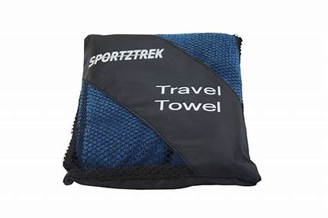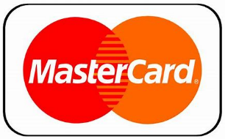

**Happy Responsible Travelling**